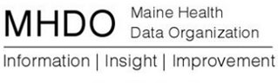

Payer User Group
Agenda
July 24, 2013
2:30 p.m. - 3:30 p.m. EST
Call In Number: 1-877-455-0244
Conference Code: 7281882859

- Feedback from Beta Testing
- Timeline
- Threshold Validations

- Status of Internal State Deployment Certification
- Other

